EX.NO: 3 | Survey report on Emerging Trends in low-code application Development

SAHANA R
241401086
Abstract:
Recent research shows that low-code development is moving beyond simple drag-and-drop application building toward AI-assisted development, citizen development, automation, cloud integration, governance, and enterprise-scale applications. Gartner’s 2025 forecast, for example, projects the low-code development technologies market to reach $58.2 billion by 2029, with AI agents and citizen development among the major adoption drivers.
Table of Contents
S.No | Contents
1. | Introduction
2. | Overview of Low-Code Application Development
3. | Objectives and Research Methodology
4. | Emerging Trends in Low-Code Development
5. | Survey Questionnaire and Data Collection
6. | Data Analysis and Statistical Interpretation
7. | Charts and Graphical Representation
8. | Benefits and Challenges of Low-Code Development
9. | Real-World Applications and Future Trends
10. | Findings and Conclusion

1. Introduction
Low-code application development is a modern software development approach that uses visual interfaces, drag-and-drop tools, reusable components, and minimal coding. It enables both developers and non-technical users to build applications faster. Modern low-code platforms also integrate AI, automation, data, and cloud services, making application development easier and more efficient.

2.Overview of Low-Code Application Development
The evolution of application development can be represented as:
Traditional Coding → RAD → Low-Code → No-Code → AI-Assisted Low-Code → AI Agent-Based Development
Traditional Development
Developers manually write code using languages such as:
- Java
- Python
- C#
- JavaScript
- PHP
Low-Code Development
Developers use:
- Drag-and-drop interfaces
- Visual workflows
- Pre-built components
- Database connectors
- APIs
- Reusable templates
AI-Assisted Low-Code
The newest stage adds:
- Natural-language prompts
- AI-generated application components
- AI-assisted workflows
- Automated data processing
- AI agents
- Intelligent recommendations
Gartner's 2026 market analysis notes that leading low-code platforms are increasingly embedding agentic AI directly into development environments.

3. Objectives and Research Methodology
Objectives
The main objectives of this survey are:
- To understand awareness of low-code development.
- To identify emerging trends in low-code technology.
- To study the benefits and challenges of low-code platforms.
- To understand the role of AI in low-code development.
- To analyze users' future interest in low-code platforms.
Research Methodology
The study uses a survey-based research method. Data can be collected using Google Forms from students, developers, faculty, and IT professionals. The collected responses are analyzed using frequency, percentage, tables, charts, and graphs.

4. Emerging Trends in Low-Code Development
Low-code development is evolving rapidly with new technologies.
Major emerging trends:
AI-Assisted Development: AI helps generate applications, workflows, formulas, and code from natural-language instructions.
Citizen Development: Non-programmers can create applications for their business requirements.
Workflow Automation: Repetitive tasks such as approvals, notifications, and data entry can be automated.
Cloud Integration: Applications can easily connect with cloud databases and services.
Data Analytics: Low-code platforms provide dashboards, reports, and data visualization.
AI Agents: Newer platforms are moving toward AI agents that can perform multi-step tasks with less manual configuration.

5. Survey Questionnaire and Data Collection
A questionnaire is prepared to understand people's awareness, experience, opinions, and expectations regarding low-code development.
Sample questions:
- Are you aware of low-code development?
- Have you used a low-code platform?
- Which low-code platform have you used?
- What is the main benefit of low-code development?
- Which emerging trend is most important?
- What is the biggest challenge?
- Do you think AI will increase low-code adoption?
- Would you use low-code platforms in future?
The survey responses are collected through Google Forms and organized for further analysis.

6. Data Analysis and Statistical Interpretation
The collected survey data is analyzed to identify patterns and trends.
Percentage
Percentage is calculated using:
Percentage = (Number of responses / Total responses) × 100
Frequency
Frequency represents the number of respondents selecting a particular answer.
Mean
Mean can be used for questions based on a rating scale such as:
1 = Strongly Disagree → 5 = Strongly Agree
Example
If 70 out of 100 respondents are aware of low-code development:
Percentage = (70 / 100) × 100 = 70%
The results help identify the overall awareness, adoption, benefits, and concerns related to low-code development.
7. Charts and Graphical Representation
Charts make the survey results easier to understand and compare.
Awareness of Low-Code Development
Experience with Low-Code Platforms
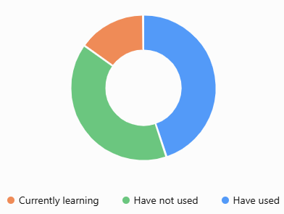
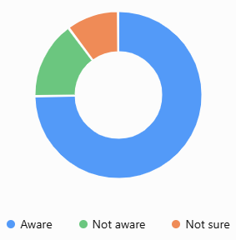

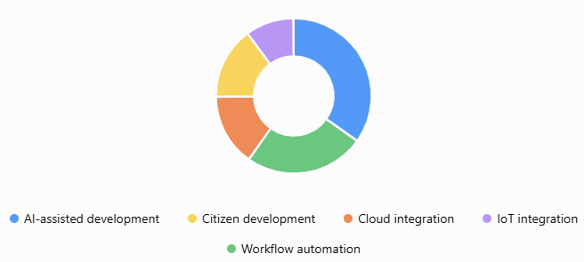
Most Important Emerging Trend

8. Benefits and Challenges of Low-Code Development
Benefits
- Faster application development
- Reduced coding effort
- Lower development cost
- Easy prototyping
- Workflow automation
- Improved productivity
- Easier collaboration
- Greater participation from non-programmers
Challenges
- Security concerns
- Vendor lock-in
- Limited customization for complex applications
- Scalability issues
- Governance requirements
- Dependence on the platform
- Need for skilled developers for advanced applications
Therefore, low-code provides speed and simplicity but still requires proper planning and governance.
9. Real-World Applications and Future Trends
Low-code platforms are used in many areas such as:
- Healthcare: Patient management systems
- Education: Student management applications
- Banking: Internal workflow applications
- Retail: Inventory and sales management
- Manufacturing: Production monitoring
- Human Resources: Employee management
- Business: Customer and process management
Future Trends
The future of low-code development is expected to focus on:
AI + Low-Code + Cloud + Automation + Data Analytics + AI Agents
AI will increasingly help users create applications through natural-language instructions, while low-code platforms will continue to support faster business application development.

10. Findings and Conclusion
Findings
The survey can be used to identify:
- The level of awareness of low-code development.
- The most commonly used platforms.
- The most important emerging trends.
- Major benefits expected by users.
- Main challenges affecting adoption.
- The expected impact of AI.
- Users' willingness to adopt low-code platforms in the future.
Comparison of Different Low-Code Platforms
Platform | Main Use | Easy to Use | Customization | Integration | Best Suitable For
Zoho Creator | Creating business applications | Very Easy | High | Good | Small businesses and students
Microsoft Power Apps | Business apps and automation | Very Easy | High | Excellent | Organizations using Microsoft products
OutSystems | Enterprise application development | Easy | Very High | Excellent | Large organizations
Mendix | Web and mobile applications | Easy | Very High | Excellent | Enterprise-level applications
Appian | Workflow and process automation | Easy | High | Excellent | Business process management
Salesforce Platform | CRM and customer applications | Easy | High | Excellent | Sales and customer management

Conclusion
Low-code platforms have made software development easier, faster, and more accessible. Platforms such as Zoho Creator, Microsoft Power Apps, OutSystems, Mendix, Appian, and Salesforce provide visual tools, drag-and-drop features, workflow automation, and ready-made components that reduce the need for writing large amounts of code.
Each platform has its own strengths. Zoho Creator and Power Apps are easy to use and suitable for beginners and small businesses, while OutSystems and Mendix are better for large and complex applications. Appian is mainly useful for process automation, whereas Salesforce is widely used for CRM and customer-related applications.
Overall, low-code platforms help organizations reduce development time, cost, and effort while allowing applications to be built quickly and efficiently. However, traditional programming is still important for highly customized and complex systems. Therefore, the best choice of platform depends on the organization's requirements, budget, technical skills, and application complexity.

